**Paediatric Clinical Experience**

**Discover What It’s Like at the Osteopathic Centre for Children (OCC)**

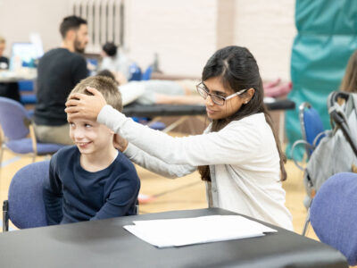At the Osteopathic Centre for Children, clinical learning is at the heart of everything we do. We offer an immersive, hands-on experience that is unlike any other paediatric osteopathy clinic. Our approach ensures that you develop your skills quickly, efficiently, and effectively—helping you become a confident and capable paediatric osteopath in less time.

If you’re considering working in paediatrics, are interested in joining our post-graduate courses, or simply want to experience our unique paediatric clinic, come and join our **Paediatric Clinical Experience.**

**Free Half Day Paediatric Clinical Experience**

Our free clinical experience offers a unique opportunity to discover what it’s like working with children in our paediatric clinic. You’ll gain insight into the high level of clinical learning and collaborative care that form the foundation of our clinic.

This is an introductory offer for those wanting to experience our clinic for half a day. There are limited places available so please book quickly. Allocation of places will be discretionary.

**Paid Paediatric Clinical Experience**

For those wanting a deep dive into paediatric osteopathy providing unparalleled learning alongside expert practitioners, we also offer paid paediatric clinical experience.

You will have the opportunity to attend tutorials with experienced paediatric osteopaths, providing valuable insights into diagnosis and treatment planning. You will also receive a recognised CPD Certificate for your professional portfolio (7 credits for a full day, 3.5 credits for half a day).

* **Cost:** £120 (full day) / £60 (half day)
* **Hours:**
  + Full day: 8:45 AM – 5:30 PM
  + Half day: 8.45am -1pm (morning) or 2pm – 5pm (afternoon)
* **Locations:** Warren Street or Shoreditch Clinic

|  |  |  |
| --- | --- | --- |
|  | **Free Paediatric Clinical Experience** | **Paid Paediatric Clinical Experience** |
| **Tutorials with Experts:**  Attend sessions led by seasoned paediatric osteopaths, providing valuable insights into diagnosis and treatment planning. | X | √ |
| **CPD Certificate:** Receive a recognised CPD certificate at the end of the day, enhancing your professional portfolio. | X | √ |
| **Observation Opportunities:** Watch experienced practitioners treat a diverse range of paediatric cases, including complex patients. | √ | √ |
| **Collaborative Learning:**  Participate in case discussions and collaborative care alongside experts in the field. | √ | √ |
| **Invaluable Clinical Exposure:**  Gain experience in a real-world paediatric clinic setting. | √ | √ |
| **Fast-Track Your Development:**  Benefit from the OCC’s unique clinical learning environment, proven to be the most effective way to refine your skills and expand your practice. | √ | √ |
| **See a variety of Paediatric Cases:** Experience the variety of paediatric conditions we treat and see first-hand how we approach complex cases with expert care and skill. | √ | √ |
|  |  |  |

**Dates in our Warren Street clinic:**

* + Tuesday 21st January
  + Tuesday 18th February
  + Tuesday 18th March

**Location:**141 Cleveland Street, London, W1T 6QG

**Dates in our Shoreditch Street clinic:**

* + Thursday 30th January
  + Thursday 27th February
  + Thursday 20th March

**Location:**85 Pitfield Street, London, N1 6NP